CATEGORY-WISE PRODUCT ANALYSIS REPORT
The Category-wise Product Analysis is used to understand the products available under each category. SQL queries are used to display products, count products, find the highest price, calculate the average price and display product prices category-wise.

1. Display All Products Under Each Category
This query displays all products along with their category name, price and stock quantity.

SQL Query
SELECT c.Category_Name, p.Product_Name, p.Price, p.Stock_Quantity
FROM Category c
JOIN Product p ON c.Category_ID = p.Category_ID
ORDER BY c.Category_Name, p.Product_Name;
Figure 1: Products Under Each Category.
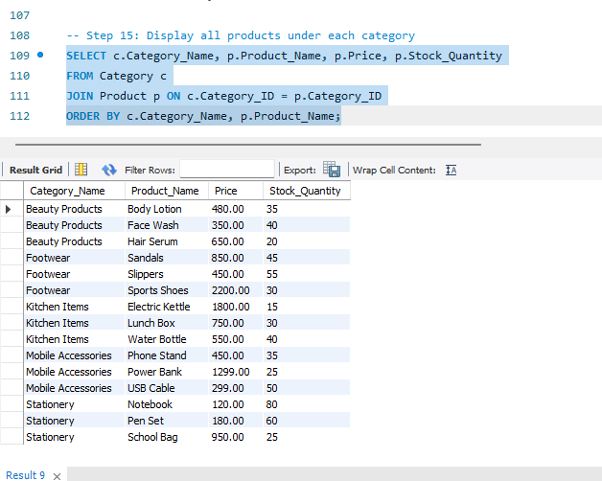

2. Count Number of Products in Each Category
This query counts the total number of products available in each category.

SQL Query
SELECT c.Category_Name, COUNT(p.Product_ID) AS Total_Products
FROM Category c
LEFT JOIN Product p ON c.Category_ID = p.Category_ID
GROUP BY c.Category_Name;
Expected Result:
Category Name | Total Products
Mobile Accessories | 5
Footwear | 5
Stationery | 5
Kitchen Items | 5
Beauty Products | 5
Figure 2: Product Count by Category
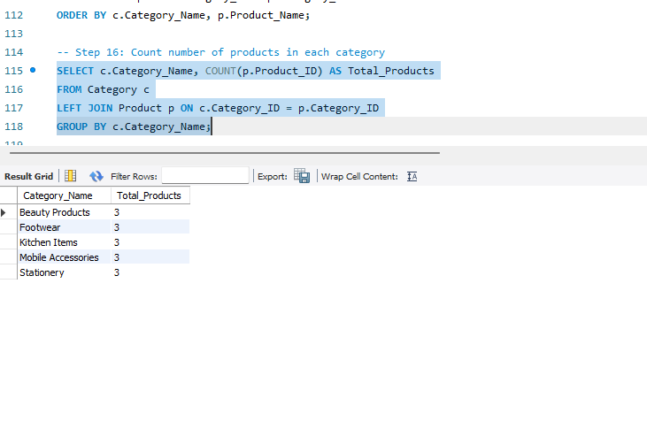

3. Find Highest-Priced Product in Each Category
This query finds the product with the highest price in each category.

SQL Query
SELECT c.Category_Name, p.Product_Name, p.Price
FROM Product p
JOIN Category c ON p.Category_ID = c.Category_ID
WHERE p.Price = (
SELECT MAX(p2.Price)
FROM Product p2
WHERE p2.Category_ID = p.Category_ID
);
Expected Result:
Category Name | Highest-Priced Product | Price
Mobile Accessories | Bluetooth Speaker | 1499.00
Footwear | Sports Shoes | 2200.00
Stationery | School Bag | 950.00
Kitchen Items | Electric Kettle | 1800.00
Beauty Products | Hair Serum | 650.00
Figure 3: Highest-Priced Product in Each Category
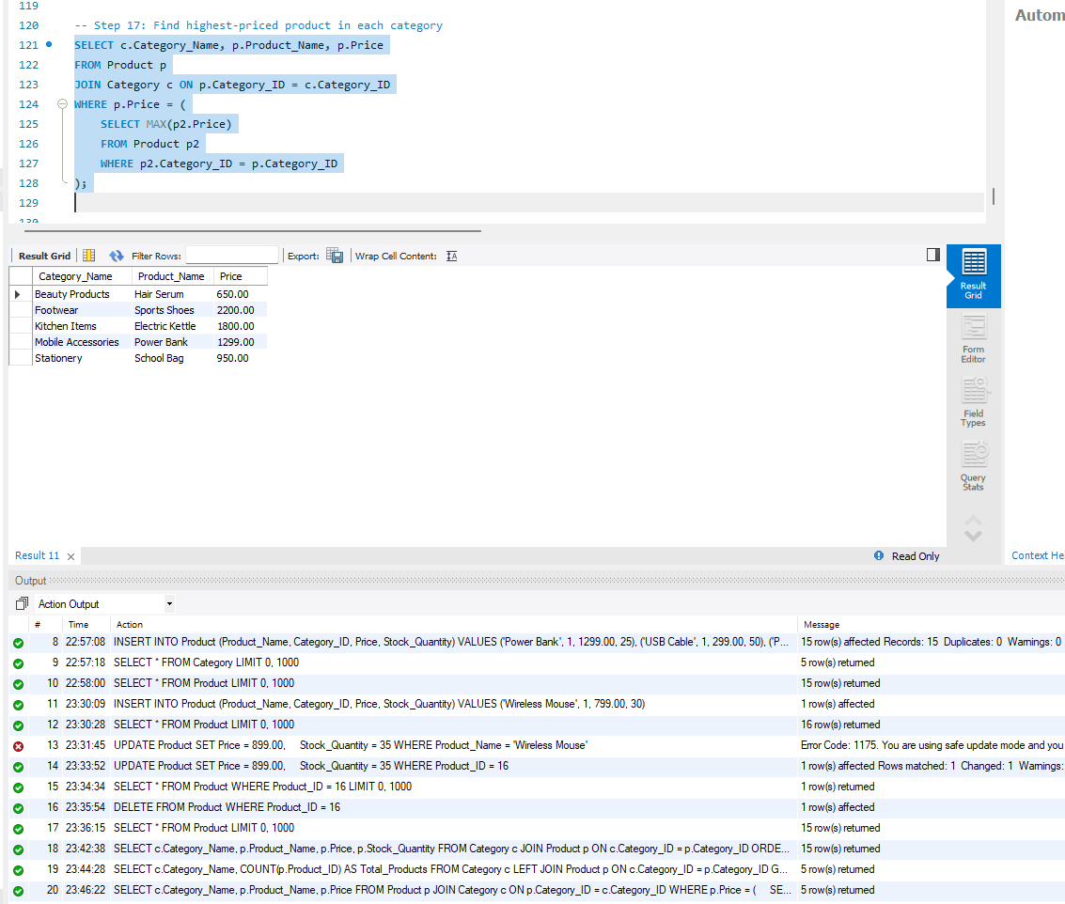

4. Display Categories Having Exactly 5 Products
This query displays the categories that contain exactly five products.

SQL Query
SELECT c.Category_Name, COUNT(p.Product_ID) AS Total_Products
FROM Category c
JOIN Product p ON c.Category_ID = p.Category_ID
GROUP BY c.Category_Name
HAVING COUNT(p.Product_ID) = 5;
Expected Result:
Category Name | Total Products
Mobile Accessories | 5
Footwear | 5
Stationery | 5
Kitchen Items | 5
Beauty Products | 5
Figure 4: Categories Having Exactly 5 Products
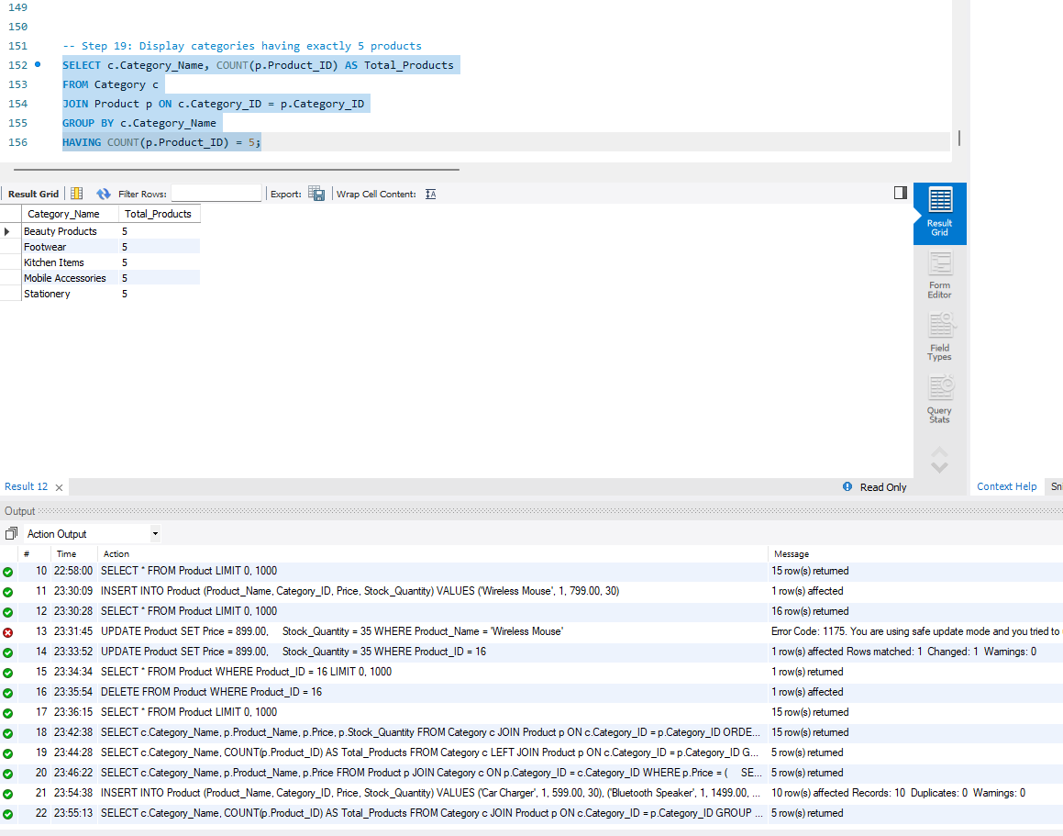

5. Find Average Product Price Category-Wise
This query calculates the average price of products in each category.

SQL Query
SELECT c.Category_Name, ROUND(AVG(p.Price), 2) AS Avg_Price
FROM Category c
JOIN Product p ON c.Category_ID = p.Category_ID
GROUP BY c.Category_Name;
Expected Result:
Category Name | Average Price
Mobile Accessories | 787.20
Footwear | 1090.00
Stationery | 330.00
Kitchen Items | 930.00
Beauty Products | 442.00
Figure 5: Average Product Price Category-Wise
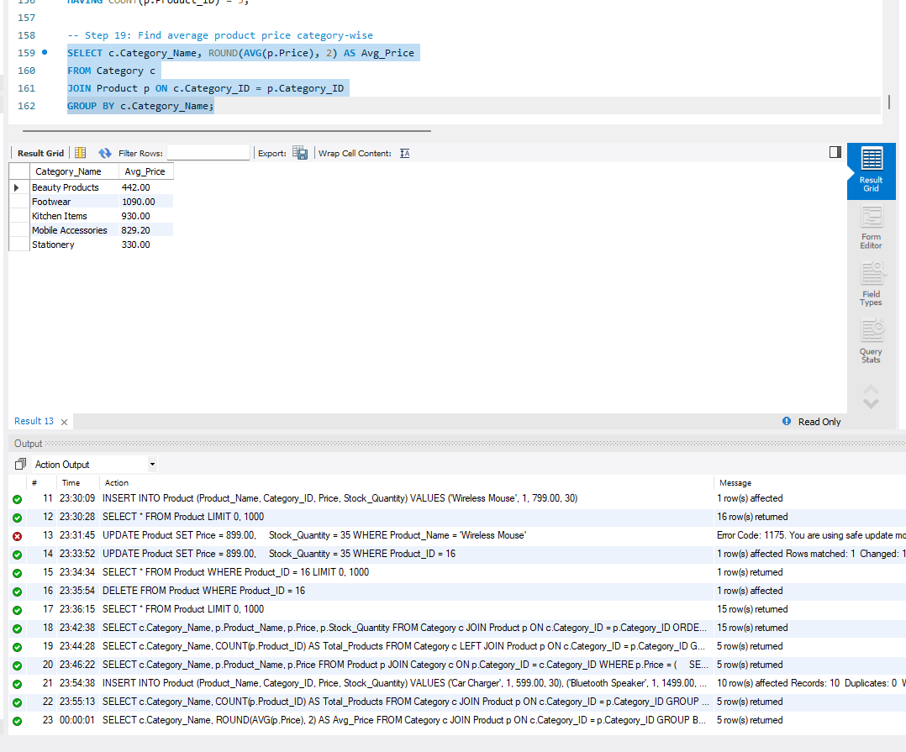

6. Find Product Price Category-Wise
This query displays each product with its category and price.

SQL Query
SELECT c.Category_Name, p.Product_Name, p.Price
FROM Category c
JOIN Product p ON c.Category_ID = p.Category_ID
ORDER BY c.Category_Name, p.Price;
Figure 6: Product Price Category-Wise
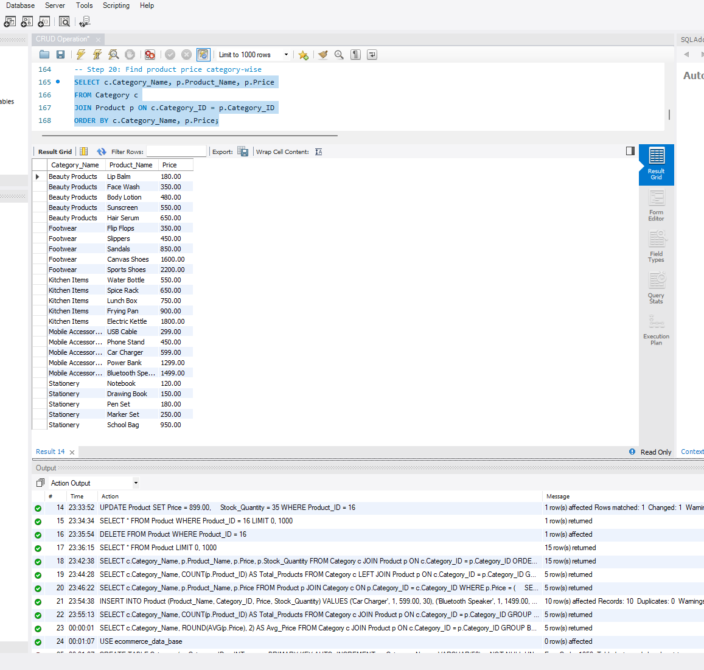

7. Analysis Summary
The analysis shows that each category contains 5 products. The Footwear category has the highest average price of ₹1,090.00, while Stationery has the lowest average price of ₹330.00. The highest-priced product overall is Sports Shoes, priced at ₹2,200.00.

8. Conclusion
The category-wise analysis helps to understand the products, product count and pricing information in each category. The SQL queries successfully provide useful information about product distribution and prices across all categories.

